SINGAPORE PORT
Vessel Congestion & Delay Analysis
Report Date: 23 April 2026
Author: Yan
______________________________________________________________________________________

Content
1. Dataset Overview
2. Vessel Delay Analysis
3. Vessel Congestion Analysis
4. Recommendations
5. Appendix

_______________________________________________________________________________________

1.Dataset Overview
_______________________________________________________________________________________

Data Period
1 October 2023 – 31 October 2023
Dataset used - AIS Data from 11 ports around the globe – Singapore port
Source Dataset
Using Automatic Identification System (AIS) data from October 2023, I tracked 600k+ vessel observations across 5,877 unique ships over 30 days of dataset from University of St Andrews, Scotland, created by Andreas Hadjipieris (Creator), Neofytos Dimitriou (Creator) Oggie Arandelovic (Creator) School of Computer Science.
Scope
609,468 AIS records — 5,877 unique vessels — 14 vessels types

Executive Summary
This report presents a comprehensive analysis of vessel congestion and delay conditions observed at Singapore Port during October 2023, derived from Automatic Identification System (AIS) data covering 609,468 records across 6016 unique vessels. The analysis encompasses spatial congestion mapping, delay severity profiling, vessel-type breakdowns, and identification of the most critically affected vessels and zones.

2.Vessel Delay Analysis

_____________________________________________________________________________________________

Delayed Vessels  3967 | Avg Daily Static Rate  69.13%  anchored or moored — every day | Avg Daily Delay %  66.85% | Avg Delay Day  17.47  mean days past ETA
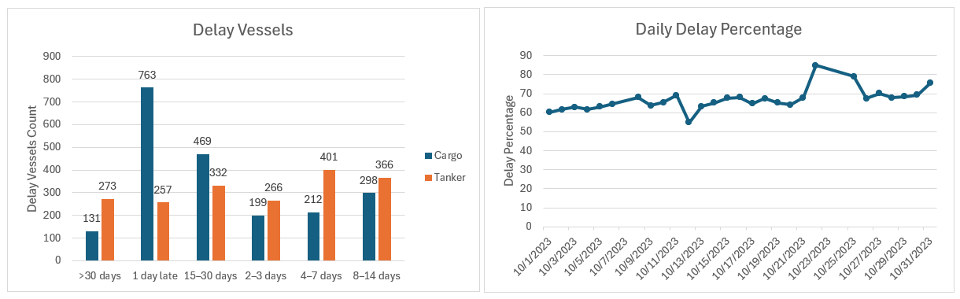

Insights

System-Wide Delay
The 60%-70% delay ratio holds every single day throughout October regardless of traffic volume or day of week, confirming a chronic port capacity constraint rather than an episodic or weather-driven event.

Cargo Vessels short-term Delay
Cargo vessels dominate the "1 day late" category (763 vessels). This suggests that while Cargo ships are frequently delayed, the delays are often short-term and potentially manageable through better scheduling.

The "15–30 Day" Cargo Surge
Notable spike for Cargo vessels in the 15–30 days delay category after 1 day late. It seems like if they miss their window significantly, they appear to get "stuck" for a minimum of two weeks. This could be due to missing a specific feeder connection or losing their slot in a highly congested queue.

Long-Tail Delays
Tankers are much more likely than Cargo ships to be delayed for >30 days (273 vs 131) and 4–7 days (401 vs 212).
Tankers may be facing specific bottlenecks such as berth availability for liquid bulk or longer bunkering/safety inspections that don't affect standard cargo ships.

Delay by vessel type — sorted by average maximum delay
Vessel Type | Vessels | Avg Max Delay | Median Max Delay | % Over 30 Days | Avg Draught (m)
Tanker (Reserved) | 34 | 40.1 days | 10.0 days | 27% | 6.4m
General Tanker | 1710 | 16.9 days | 5.0 days | 12% | 10.2m
Tanker (Hazard C) | 41 | 15.2 days | 4.0 days | 17% | 7.7m
Cargo Vessel (Hazard B) | 38 | 15.2 days | 4.0 days | 8% | 11.0m
Tanker (No info) | 307 | 15.1 days | 4.0 days | 10% | 11.0m
Tanker (Hazard D) | 82 | 13.1 days | 3.0 days | 11% | 9.1m
Tanker (Hazard A) | 113 | 12.1 days | 5.0 days | 8% | 9.3m
Cargo Vessel (No info) | 280 | 10.1 days | 1.0 days | 6% | 11.0m
Cargo Vessel (Reserved) | 22 | 10.0 days | 1.5 days | 9% | 10.6m
Tanker (Hazard B) | 172 | 9.3 days | 4.5 days | 6% | 8.5m
Cargo Vessel (Hazard A) | 421 | 8.2 days | 1.0 days | 6% | 12.0m
Cargo Vessel (Hazard C) | 35 | 7.6 days | 5.0 days | 0% | 11.7m
Cargo Vessel (Hazard D) | 112 | 7.6 days | 3.0 days | 3% | 11.9m
General Cargo Vessel | 2598 | 5.3 days | 1.0 days | 3% | 10.8m

Insights
Delay severity varies substantially across vessel types. Tanker variants consistently experience the longest average maximum delays, with General Tankers averaging 16.9 days and Tanker (Reserved) class vessels averaging 40.1 days. Cargo vessel types, while more numerous, show shorter average delays but remain significantly above acceptable thresholds.

The Draught Paradox
Draught Band | Interpretation
0–5 m (shallow) | Possible Low-priority queue
5–10 m | Standard feeder vessel range
10–15 m | Best-served segment
15–20 m | Large vessel; adequate berth availability
20–25 m (deep) | Deep-water berth scarcity; constrained access

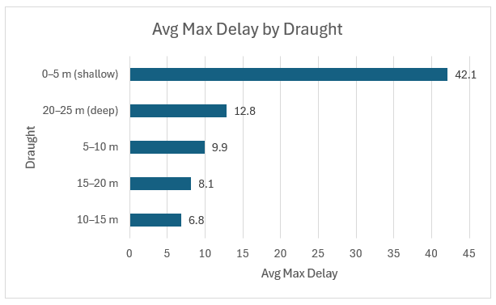

Insights
Analysis by vessel draught band reveals a counterintuitive pattern. Shallow-draft vessels (0–5m) suffer the longest average delays at 42.1 days, with 27% waiting more than 30 days. This is likely attributable to lower port priority scheduling and a higher proportion of small, independent operators without berth pre-booking. Deep-draft vessels (20–25m) also experience elevated delays of 12.8 days due to limited deep-water berth availability. Mid-range vessels (10–15m draught) are best served, averaging only 6.8 days.

3.Vessel Congestion Analysis

_____________________________________________________________________________________________

Average Daily Moving Vessels  901 | Average Daily Anchor/Moored Vessels  627 | Average SOG  (knots)  6.4 | Average Turnaround Time  5.55 days  Duration a ship spends in port | Average Berth Waiting Time  3.07 days  From anchor to moored

Red Flag Turnaround time

According to UN Trade and Development (UNCTAD), an average turnaround time of nearly 6 days is a red flag—especially for time-sensitive container or cargo ships.
Insights
Actual Working Time (Derived): 2.48 days (5.55 - 3.07)
Vessels are spending 55% of their total time in port just waiting at anchor for a berth to open up. This means the actual operational work (loading, unloading, or refueling) takes less than 2.5 days, but the queue adds an extra 3 days of dead time. The primary bottleneck is not the speed of the cranes or the dockworkers; it is a severe lack of available berth space.

Fairway Speed reflects High Traffic
An average speed of 6.4 knots for moving vessels is standard for safe maneuvering inside congested port limits. However, navigating 901 moving vessels around a daily obstacle course of 627 parked vessels requires strict traffic management.

Vessel Turnaround time
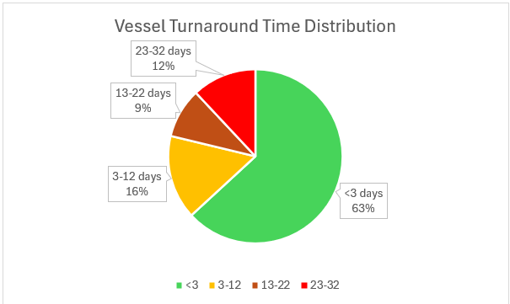
TAT days | Cargo Vessels | Tanker Vessels | Total Vessels
<3 | 2650 | 1149 | 3799
3-12 | 378 | 562 | 940
13-22 | 256 | 301 | 557
23-32 | 247 | 473 | 720

Insights

Overall Port Efficiency is High
The port successfully processes the vast majority of its traffic with high efficiency. 63% of all vessels (3,799 out of 6,016) turn around in less than 3 days.

The "23-32 Day" Anomaly is Driven by Tankers
There is a concerning spike at the tail end of the distribution: 12% of all vessels are staying in the port for almost an entire month (23-32 days). Covered deep analysis on Tanker Anomaly in the next section.

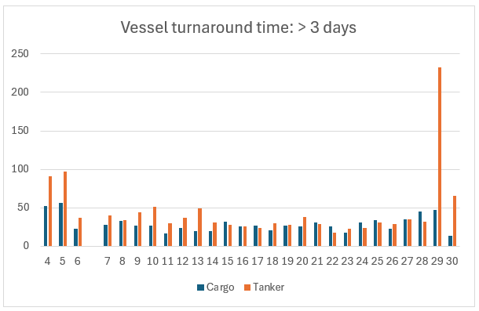

Plotting of tankers vessels (TAT >= 29 days)
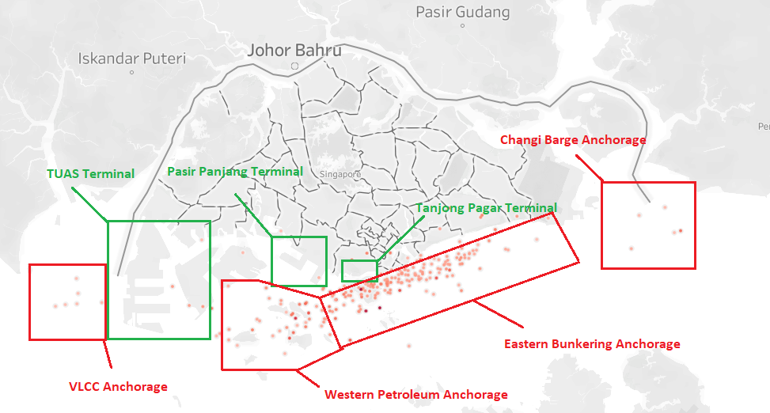

Insights

Analysis of the vessel turnaround time (TAT) distribution reveals an upper-tail cluster of 299 tankers recording durations of 29 to 30 days. Geospatial mapping confirms that these are not delayed transit vessels, but rather Bunker Tankers and Floating Storage Units (FSUs). These assets are permanently stationed within designated offshore anchorage zones to facilitate oil storage and refueling operations, distinct from standard berth-cycling traffic.

Density Headmap of all the AIS activities of Singapore Port
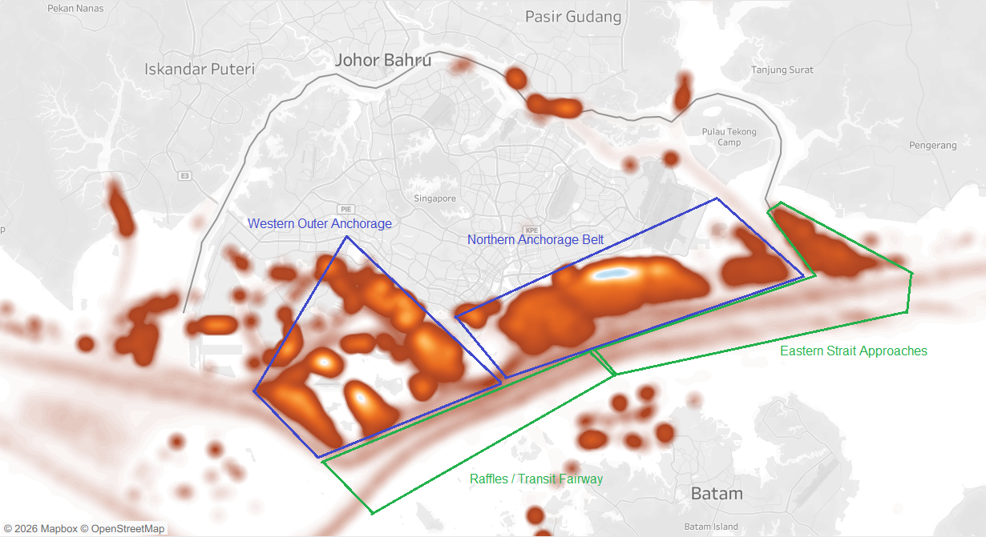

Congestion Zones
Zone | Coordinates | Anchor Rate | Role | Status
Northern Anchorage Belt | 1.25–1.30°N, 103.85–104.05°E | 61–92% | Primary vessel waiting area and primary anchorage area for Bunker tankers and FSUs. | SATURATED
Western Outer Anchorage | 1.15–1.20°N, 103.65–103.75°E | 68–78% | Overflow queue — inner belt full | SATURATED
Raffles / Transit Fairway | 1.15–1.20°N, 103.80–103.90°E | 2–33% | Active transit corridor — vessels passing | FLOWING
Eastern Strait Approaches | 1.25°N, 104.10–104.20°E | 13–24% | Inbound / outbound transit lane | FLOWING

Top 10 Congestion Hotspots
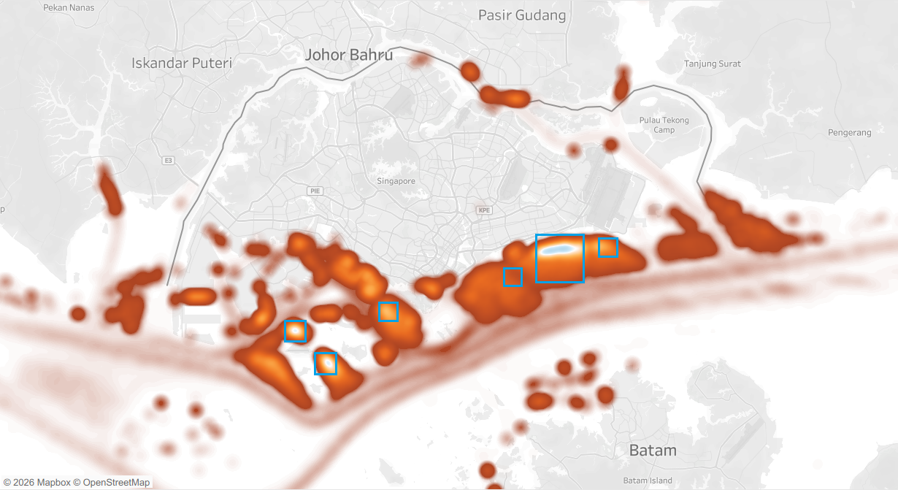

Zone (lat·long) | Total Records | Unique Vessels | Anchor % | Avg Speed (knot)
1.30°N · 103.96°E | 9334 | 170 | 53.5% | 0.17
1.30°N · 103.95°E | 7862 | 146 | 49.4% | 0.18
1.30°N · 103.97°E | 7305 | 182 | 62.3% | 0.18
1.19°N · 103.75°E | 6851 | 210 | 81.4% | 0.26
1.29°N · 103.94°E | 6596 | 248 | 64.8% | 0.4
1.30°N · 103.99°E | 6409 | 170 | 62.3% | 0.2
1.24°N · 103.80°E | 6252 | 182 | 91.3% | 0.12
1.22°N · 103.72°E | 6201 | 98 | 51.8% | 0.15
1.29°N · 103.95°E | 5531 | 270 | 66.7% | 0.49
1.29°N · 103.96°E | 5385 | 242 | 70.5% | 0.48

Insight

The data shows that congestion is primarily driven by anchorage demand rather than vessel movement, indicating a queueing system outside port boundaries. This suggests that berth allocation and port turnaround efficiency are key bottlenecks.
Distress Vessels

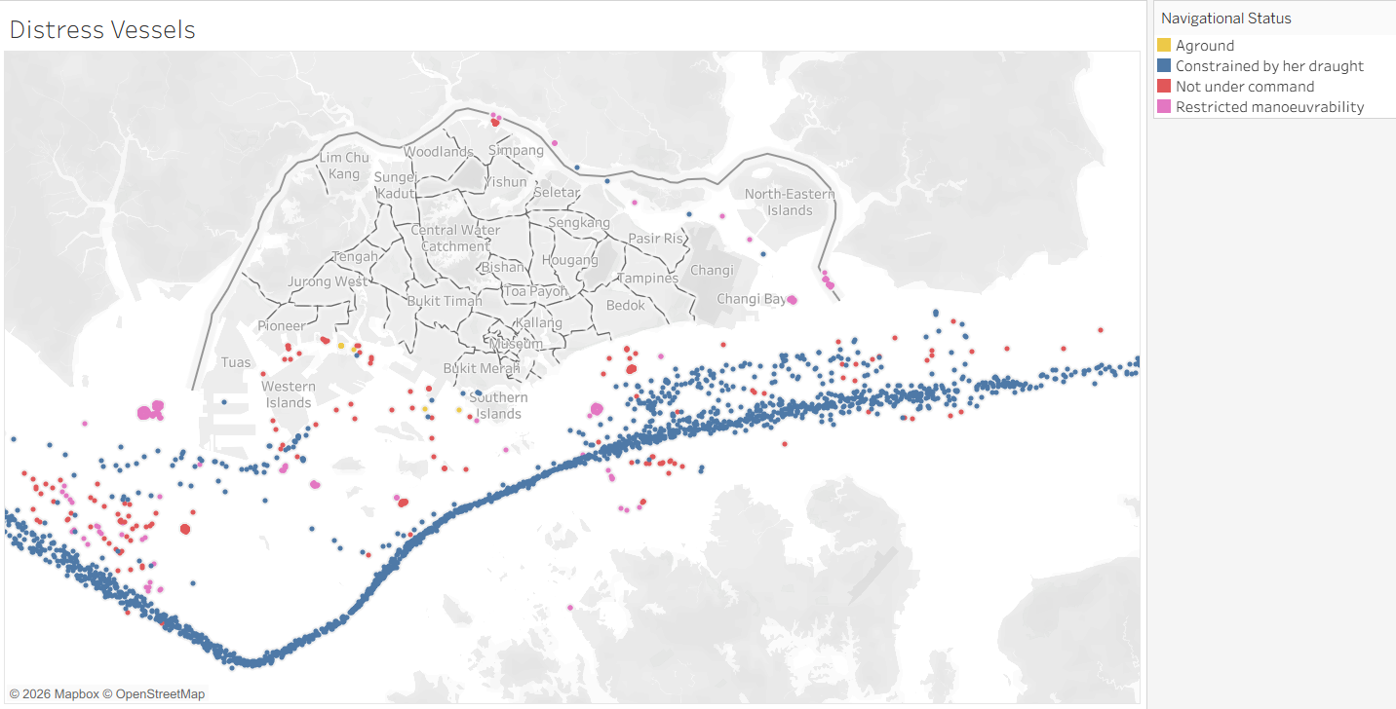

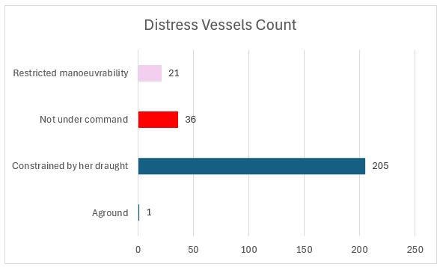

Constrained Vessels Insight
Constrained vessels dominate among the distress vessels with 77.95% of all distress vessels.

Strategic Choke Points
The grouping of blue dots is most intense between longitudes 103°48'E and 104°05'E (near St. John’s Island and the Phillips Channel). This is the narrowest part of the Singapore Strait, where navigable depth is most critical for these massive ships.

NUC Vessels and Aground Vessel

Aground Vessel NUC Vessels
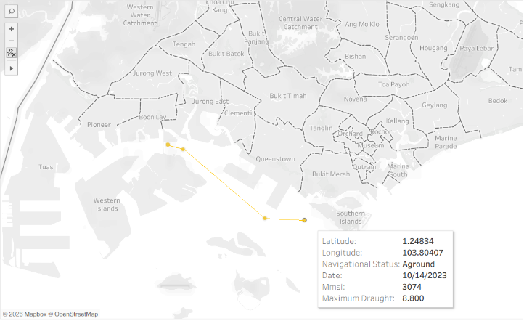
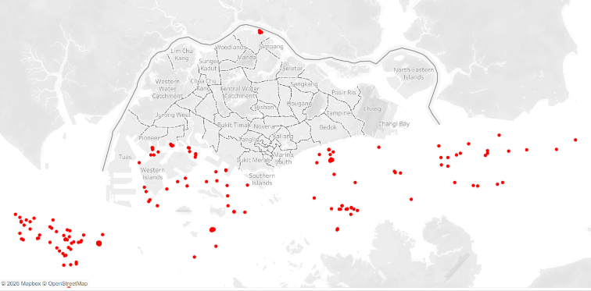

Insights

There is one Aground Vessel that run aground South of Jurong Island from 12 Oct 2023 to 14 Oct 2023  Location Risk: This area is near the Western Islands, a zone with complex tidal currents and varying depths. For a vessel with nearly 9 meters of draught, even slight deviations from the charted fairway can lead to groundings.  Impact: Groundings in the Singapore Strait are treated with extreme urgency by the Maritime and Port Authority (MPA) due to the risk of oil spills and the potential to block critical shipping lanes like the Phillip Channel. | There 36 NUC vessels all across zones like VLCC anchorage zone, Western Outer Anchorage, Fairway transit and North Anchorage Belt.  Volume Insights: The high number of NUC signals often reflects Singapore's role as a premiere ship repair and bunkering hub. Many ships arrive "under command" but may switch their AIS status to NUC while undergoing specialized offshore maintenance that prevents them from moving immediately.

4.Recommendations
_______________________________________________________________________________________

1.Implement Dynamic "Just-In-Time" Arrivals for Cargo Vessels
Cargo vessels currently dominate the short-term delay category, with 763 ships arriving exactly one day late. Furthermore, if these vessels miss this initial window, they frequently fall into a severe 15–30 days delay surge. Establishing stricter predictive scheduling and communication could prevent manageable short-term delays from spiraling into multi-week operational losses.

2.Restructure Berthing Priority for Shallow-Draught Vessels
The data reveals a counterintuitive draught paradox where shallow-draft vessels (0–5m) suffer the most extreme average delays at 42.1 days. Developing a dedicated secondary queue or allocating specific low-priority berths for these smaller operators could rapidly clear this massive 30+ day backlog.

3.Deploy Draft-Aware Traffic Control at the Phillips Channel Choke Point
Constrained vessels account for a massive 77.95% of all distress signals. Because these distress signals are intensely clustered between longitudes 103°48'E and 104°05'E, enhanced draft-clearance protocols and targeted pilotage assistance should be mandated specifically for this narrow transit corridor to prevent grounding events.

4.Designate Dedicated Off-Fairway Repair Zones
The dataset identified 36 NUC (Not Under Command) vessels scattered across critical areas, including the VLCC anchorage and the North Anchorage Belt. Since the Northern Anchorage Belt is already classified as saturated, forcing vessels undergoing maintenance into designated off-fairway repair zones would free up vital waiting areas for active vessels.

5. Appendix
_______________________________________________________________________________________

External reference sources

- Maritime & Port Authority of Singapore
- Australian Maritime Safety Authority
- ALG | Port congestion explained
- UN trade & development | Vessel turnaround time

Key Field Definitions

Field | Definition | Notes
eta_month = 0 | No ETA declared | 75 vessels have no ETA — excluded from delay analysis
rate_of_turn = -128 | AIS sentinel: no turn information | Retained as-is in all analysis
maximum_draught | Maximum vessel draught in meters | -
speed | Speed over ground in knots | 1,616 null values; excluded from speed calculations
true_heading | Vessel heading in degrees | 64,331 null values (10.6%); COG used as fallback

_______________________________________________________________________________

About the Report
This analysis was conducted as part of Singapore port maritime data Ecosystem Project (which is the one-man project: ETL development, Delay Prediction ML model development, BI Dashboard development and Vessel Delay and Congestion Analysis.
Tools utilized: Excel, Python, Tableau, SQL

Disclaimer
This analysis is based on October 2023 AIS data and represents conditions during that specific period. Port operations, capacity, and performance metrics may have changed since data collection and should not be considered precise forecasts. Readers should consult Singapore Port management and official reports for current operational data.
END OF REPORT

